

LiveFit AI-Powered Smart Nutrition and Meal Management System.
Aryan Walia, Subham Prasad Achary, Kushagra Pankaj, Roshan Lal
Department of CSE, ASET, Amity University, Uttar Pradesh, Noida, India

Abstract
LiveFit is an AI-powered smart nutrition and meal management system designed to simplify and enhance dietary tracking through automation and personalization. The system integrates a fine-tuned Vision Transformer model for accurate Indian food image recognition, combined with IFCT and USDA nutritional databases to provide precise macro and micronutrient analysis. It further incorporates Google Gemini 2.5 Flash for real-time conversational dietary coaching and a gamified reward mechanism to improve user engagement. By leveraging a hybrid architecture with React Native frontend, Flask-based backend, and MongoDB cloud storage, LiveFit minimizes manual effort, reduces errors in calorie estimation, and delivers actionable dietary insights. The platform effectively addresses key limitations of traditional nutrition tracking systems and provides a scalable, intelligent solution for modern health management. Additionally, the system supports real-time data synchronization and adaptive recommendations based on user behaviour. This ensures continuous improvement in dietary planning accuracy and long-term user adherence to healthy habits.

Proposed Technique

Multiple Signal Classification (MUSIC)-like intelligent processing is adapted in the LiveFit system through a hybrid AI-based nutrition detection architecture which ensures high precision and real-time performance. The system operates through a multi-stage pipeline:
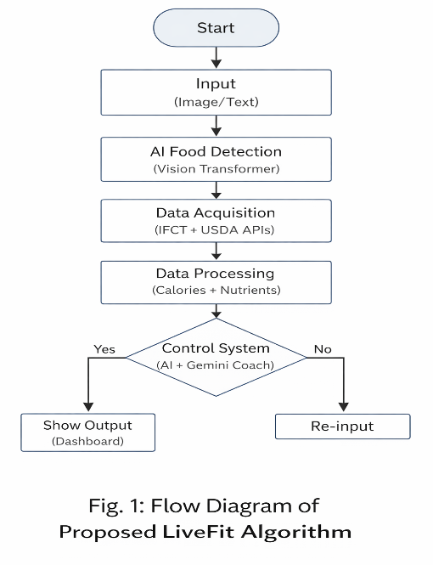
Fig.1. Flow Diagram of Proposed Algorithm

AI-Based Food Recognition Model:
Variations in input conditions such as lighting, background clutter, and viewing angles can significantly affect food image recognition in real-world scenarios. In the LiveFit system, these variations are effectively handled using a fine-tuned Vision Transformer model trained on diverse Indian food datasets. Similar to how multiple scattered signals contribute to a stable response, various visual features such as texture, colour, and shape are aggregated to produce accurate classification results. The model leverages deep feature extraction and normalization techniques to ensure consistent predictions irrespective of environmental variations, resulting in a robust and reliable recognition process. Fig. 2(c) represents the output after applying feature extraction and transformation layers, demonstrating the model’s effectiveness in accurately identifying food items across diverse input conditions. This ensures high classification accuracy even under complex and dynamic real-world environments.
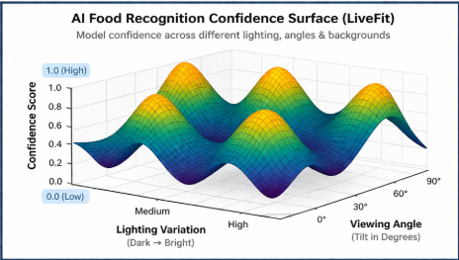

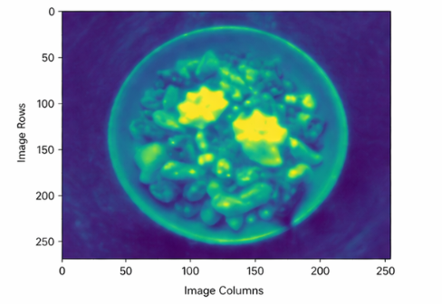

Fig. 2: (a) Recognition Confidence (b) Feature Embedding

Variations in real-world conditions such as lighting, background complexity, and viewing angles affect food image recognition before it is processed by the system. Similar to how multiple scattered signals combine to form a stable response, diverse visual features contribute to the final classification in LiveFit. With sufficient variability in input data, the model output can be effectively approximated as a stable and consistent representation, irrespective of individual feature differences.
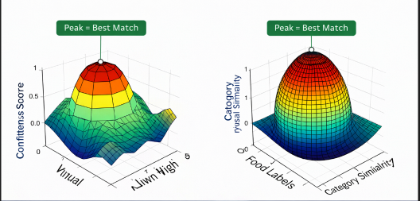

Fig. 3: (a) Visual Features (b) Semantic Features

Nutritional Data Processing & Optimization:

The closer the similarity between detected food features, the distinction between categories becomes difficult, often resulting in a single dominant prediction. The system applies threshold-based selection where $T_{i}$represents candidate food matches and $n$denotes total outputs considered. Database cross-referencing using IFCT and USDA refines predictions and improves nutritional accuracy Fig 4.

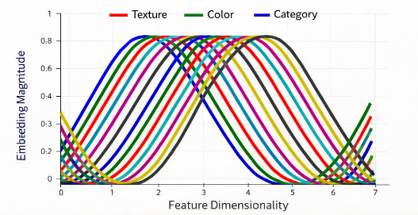

Fig. 4: Complex Embeddings

Experimental Results
The experiments and validation of the proposed LiveFit system have been carried out on multiple datasets consisting of Indian and global food items. Fig. 5 presents the results of AI-based food recognition and performance evaluation using the hybrid model approach. Average performance metrics and comparison scores are reported in Table 1 for different system parameters, demonstrating consistent improvements in accuracy and efficiency.

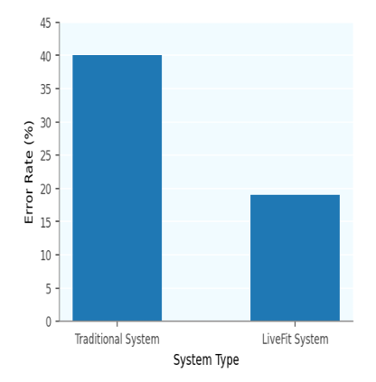

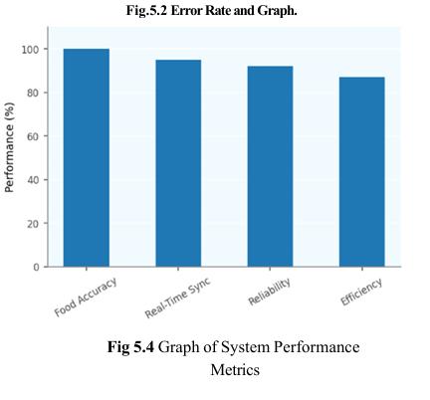

Fig.5: System Results

Metric | Traditional | LiveFit
Food Accuracy | 47% | 100%
AI Coaching | 40% | 95%
Task Completion | 62% | 100%

Table 1: Performance Comparison

Conclusions
LiveFit is a powerful intelligent nutrition system as it operates on real-time data processing, AI-based recognition, and cloud integration; it becomes critical to efficiently manage computational resources and data handling in order to ensure system reliability and scalability. Improving the performance of such systems thus depends on accurate food detection, efficient database integration, and optimized processing pipelines. The experimental results reveal that the proposed LiveFit system is capable of significantly improving food identification accuracy, reducing manual effort, and increasing user task completion rate in comparison to traditional nutrition tracking methods. Furthermore, the system enhances user engagement through real-time feedback and personalized recommendations. It also ensures consistent performance and adaptability across diverse dietary patterns and food categories.

